

ARUNAI ENGINEERING COLLEGE
(Affiliated to Anna University)
Velu Nagar, Thiruvannamalai-606603
www.arunai.org

DEPARTMENT OF ARTIFICIAL INTELLIGENCE
& DATA SCIENCE

BACHELOR OF TECHNOLOGY

2023-2024

FOURTH SEMESTER

CS3591-COMPUTER
NETWORKS LABORATORY
ACS

ARUNAI ENGINEERING COLLEGE

TIRUVANNAMALAI – 606 603

DEPARTMENT OF ARTIFICIAL INTELLIGENCE
& DATA SCIENCE
CERTIFICATE

Certified that this is a bonafide record of work done by
Name :
University Reg.No :

Semester :

Branch :

Year :

Staff-in-Charge Head of the Department

Submitted for the

Practical Examination held on

Internal Examiner External Examiner

S.NO | DATE | List Of Experiments | Pg.No | Signature
1 |  | Learn to use commands like tcpdump, netstat, ifconfig, nslookup and traceroute.,Capture ping and traceroute PDUs using a network protocol analyzer and examine
2 |  | Write a HTTP web client program to download a  web page using TCP sockets
3 |  | Applications using TCP sockets like:a)Echo client and echo server, b)Chat.
4 |  | Simulation of DNS using UDP Sockets
5 |  | Use a tool like Wireshark to capture packets and examine the packets
6 |  | Write a code simulating ARP /RARP protocols
7 |  | Study of Network simulator (NS) and Simulation of Congestion Control Algorithm using NS
8 |  | Study of TCP/UDP performance using Simulation tool.
9 |  | Simulation of Distance Vector/ Link State Routing algorithm
10 |  | Simulation of Error Detection Code (like CRC)

EX.NO:1 Learn to use commands like tcpdump, netstat, ifconfig, nslookup and

DATE: traceroute.,Capture ping and traceroute PDUs using a network protocol

analyzer and examine

AIM:
To Learn to use commands like tcpdump, netstat, ifconfig, nslookup and traceroute ping.

Commands:

1.Tcpdump:

Display traffic between 2 hosts:
To display all traffic between two hosts (represented by variables host1 and host2): # tcpdump host host1 and host2

Display traffic from a source or destination host only:
To display traffic from only a source (src) or destination (dst) host: # tcpdump src host
# tcpdump dst host

Display traffic for a specific protocol
Provide the protocol as an argument to display only traffic for a specific protocol, for example tcp, udp, icmp, arp
# tcpdump protocol
For example to display traffic only for the tcp traffic :
# tcpdump tcp

Filtering based on source or destination port
To filter based on a source or destination port:
# tcpdump src port ftp # tcpdump dst port http

2.Netstat

Netstat is a common command line TCP/IP networking available in most versions of Windows, Linux, UNIX and other operating systems.
Netstat provides information and statistics about protocols in use and current TCP/IP network connections. The Windows help screen (analogous to a Linux or UNIX for netstat reads as follows: displays protocol statistics and current TCP/IP network connections.

#netstat
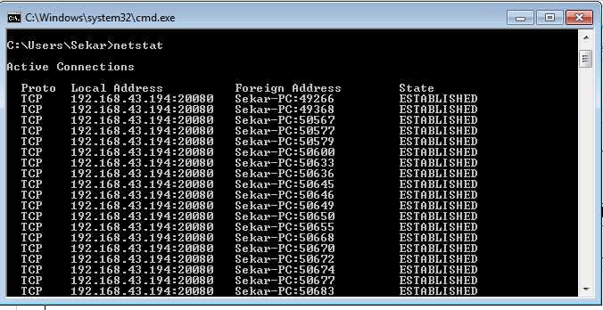

3.ipconfig

In Windows, ipconfig is a console application designed to run from the Windows command prompt. This utility allows you to get the IP address information of a Windows computer.

Using ipconfig
From the command prompt, type ipconfig to run the utility with default options. The output of the default command contains the IP address, network mask, and gateway for all physical and virtual network adapter.

#ipconfig

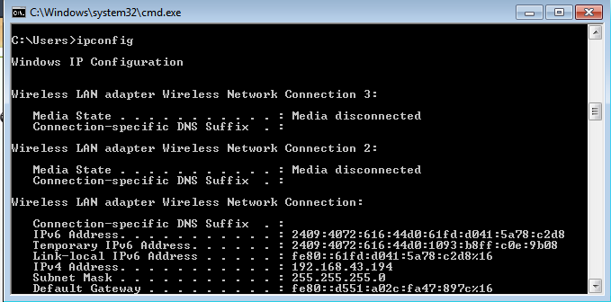

4.nslookup

The nslookup (which stands for name server lookup) command is a network utility program used to obtain information about internet servers. It finds name server information for domains by querying the Domain Name System.
The nslookup command is a powerful tool for diagnosing DNS problems. You know you're experiencing a DNS problem when you can access a resource by specifying its IP address but not its DNS name.
#nslookup

5.Trace route:

Traceroute uses Internet Control Message Protocol (ICMP) echo packets with variable time to live (TTL) values. The response time of each hop is calculated. To guarantee accuracy, each hop is queried multiple times (usually three times) to better measure the response of that particular hop.
Traceroute is a network diagnostic tool used to track the pathway taken by a packet on an IP network from source to destination. Traceroute also records the time taken for each hop the packet makes during its route to the destination. Traceroute uses Internet Control Message Protocol (ICMP) echo packets with variable time to live (TTL) values.
The response time of each hop is calculated. To guarantee accuracy, each hop is queried multiple times (usually three times) to better measure the response of that particular hop. Traceroute sends packets with TTL values that gradually increase from packet to packet, starting with TTL value of one. Routers decrement TTL values of packets by one when routing and discard packets whose TTL value has reached zero, returning the ICMP error message ICMP Time Exceeded.
For the first set of packets, the first router receives the packet, decrements the TTL value and drops the packet because it then has TTL value zero. The router sends an ICMP Time Exceeded message back to the source. The next set of packets are given a TTL value of two, so the first router forwards the packets, but the second router drops them and replies with ICMP Time Exceeded.

Proceeding in this way, traceroute uses the returned ICMP Time Exceeded messages to build a list of routers that packets traverse, until the destination is reached and returns an ICMP Echo Reply message.
With the tracert command shown above, we're asking tracert to show us the path from the local computer all the way to the network device with the hostname

www.google.com. #tracert
google.com
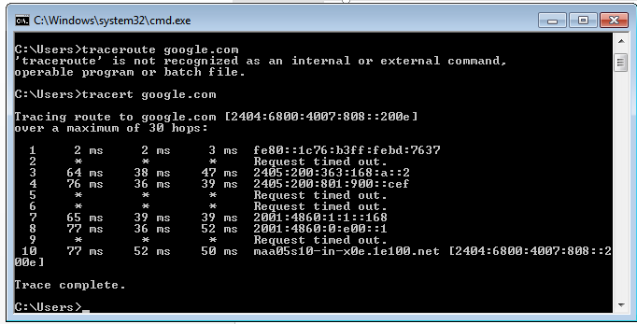
6.Ping:
The ping command sends an echo request to a host available on the network. Using this command, you can check if your remote host is responding well or not. Tracking and isolating hardware and software problems. Determining the status of the network and various foreign hosts. The ping command is usually used as a simple way to verify that a computer can communicate over the network with another computer or network device. The ping command operates by sending Internet Control Message Protocol (ICMP) Echo Request messages to the destination computer and waiting for a response
# ping172.16.6.2

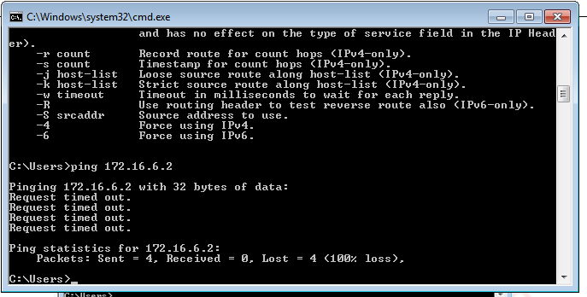

RESULT:

Thus, the various networks commands like tcpdump, netstat, ifconfig, nslookup and traceroute ping are executed successfully.

EX.NO:2 Write a HTTP web client program to download a web page using TCP sockets

DATE:

AIM:
To write a java program for socket for HTTP for web page upload and download .

ALGORITHM:

Client:
- Start.
- Create socket and establish the connection with the server.
- Read the image to be uploaded from the disk
- Send the image read to the server
- Terminate the connection
- Stop.

Server:
- Start
- Create socket, bind IP address and port number with the created socket and make server a listening server.
- Accept the connection request from the client
- Receive the image sent by the client.
- Display the image.
- Close the connection.
- Stop.

PROGRAM
Client

import javax.swing.*; import java.net.*; import java.awt.image.*; import javax.imageio.*; import java.io.*;
import java.awt.image.BufferedImage; import java.io.ByteArrayOutputStream; import java.io.File;
import java.io.IOException; import javax.imageio.ImageIO;
public class Client
{
public static void main(String args[]) throws Exception
{

");
Socket soc; BufferedImage img = null; soc=new
Socket("localhost",4000);
System.out.println("Client is running.

try {
System.out.println("Reading image from disk. ");
img = ImageIO.read(new File("digital_image_processing.jpg")); ByteArrayOutputStream baos = new ByteArrayOutputStream(); ImageIO.write(img, "jpg", baos);
baos.flush();
byte[] bytes = baos.toByteArray(); baos.close(); System.out.println("Sending image to server."); OutputStream out = soc.getOutputStream(); DataOutputStream dos = new DataOutputStream(out); dos.writeInt(bytes.length);
dos.write(bytes, 0, bytes.length); System.out.println("Image sent to server. "); dos.close();
out.close();

}
catch (Exception e)
{
System.out.println("Exception: " + e.getMessage());

soc.close();
}
soc.close();
}
}

Server

import java.net.*; import java.io.*;
import java.awt.image.*; import javax.imageio.*; import javax.swing.*; class Server
{
public static void main(String args[]) throws Exception
{
ServerSocket server=null; Socket socket;
server=new ServerSocket(4000); System.out.println("Server Waiting for image");
socket=server.accept(); System.out.println("Client connected."); InputStream in = socket.getInputStream();
 |  | DataInputStream dis = new DataInputStream(in);
 |  | int len = dis.readInt();
 |  | System.out.println("Image Size: " + len/1024 + "KB"); byte[] data = new byte[len];
 |  | dis.readFully(data);
 |  | dis.close();
 |  | in.close();
 |  | InputStream ian = new ByteArrayInputStream(data);
 |  | BufferedImage bImage = ImageIO.read(ian);
 |  | JFrame f = new JFrame("Server");
 |  | ImageIcon icon = new ImageIcon(bImage);
 |  | JLabel l = new JLabel();
 |  | l.setIcon(icon);
 |  | f.add(l);
 |  | f.pack();
 |  | f.setVisible(true);
} | }

OUTPUT:

When you run the client code, following output screen would appear on client side.
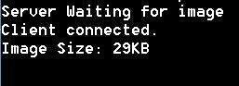

RESULT:

Thus, the socket program for HTTP for web page upload and download was developed and executed successfully.

EX.NO:3 Applications using TCP sockets like: Echo client and echo server,
DATE: Chat and File Transfer

AIM
To write a java program for application using TCP Sockets Links

a.Echo client and echo server

ALGORITHM

Client
  - Start
  - Create the TCP socket
  - Establish connection with the server
  - Get the message to be echoed from the user Send the message to the server
  - Receive the message echoed by the server
  - Display the message received from the server
  - Terminate the connection
  - Stop

Server
- Start
- Create TCP socket, make it a listening socket
- Accept the connection request sent by the client for connection establishment
- Receive the message sent by the client
- Display the received message
- Send the received message to the client from which it receives
- Close the connection when client initiates termination and server becomes a listening server, waiting for clients.
- Stop.

PROGRAM:
a.EchoServer.java import java.net.*; import java.io.*; public class EServer
{
public static void main(String args[])
{
ServerSocket s=null; String line; DataInputStream is; PrintStream ps; Socket c=null;
try
{
s=new ServerSocket(9000);
}
catch(IOException e)
{

}
try
{
System.out.println(e);

c=s.accept();
is=new DataInputStream(c.getInputStream());
ps=new PrintStream(c.getOutputStream()); while(true)
{
line=is.readLine(); ps.println(line);
}
}
catch(IOException e)
{
System.out.println(e);
}
}
}

EClient.java
import java.net.*; import java.io.*; public class EClient
{ public static void main(String arg[])
{
Socket c=null; String line;
DataInputStream is,is1; PrintStream os;
try
{
InetAddress ia = InetAddress.getLocalHost(); c=new Socket(ia,9000);
}
catch(IOException e)
{

}
try
{
System.out.println(e);

os=new PrintStream(c.getOutputStream()); is=new DataInputStream(System.in);
is1=new DataInputStream(c.getInputStream()); while(true)
{
System.out.println("Client:"); line=is.readLine();

os.println(line);
System.out.println("Server:" + is1.readLine());
}
}
catch(IOException e)
{
System.out.println("Socket Closed!");
}
}}

OUTPUT

Server
C:\Program Files\Java\jdk1.5.0\bin>javac EServer.java C:\Program Files\Java\jdk1.5.0\bin>java EServer C:\Program Files\Java\jdk1.5.0\bin>

Client
C:\Program Files\Java\jdk1.5.0\bin>javac EClient.java C:\Program Files\Java\jdk1.5.0\bin>java EClient Client: Hai Server
Server:Hai Server Client: Hello Server:Hello Client:end Server:end Client:ds
Socket Closed!

B.Chat

ALGORITHM

Client
- Start
- Create the UDP datagram socket
- Get the request message to be sent from the user
- Send the request message to the server
- If the request message is “END” go to step 10
- Wait for the reply message from the server
- Receive the reply message sent by the server
- Display the reply message received from the server
- Repeat the steps from 3 to 8
- Stop

Server
- Start
- Create UDP datagram socket, make it a listening socket
- Receive the request message sent by the client
- If the received message is “END” go to step 10
- Retrieve the client’s IP address from the request message received
- Display the received message
- Get the reply message from the user
- Send the reply message to the client
- Repeat the steps from 3 to 8.
- Stop.

PROGRAM

UDPserver.java import java.io.*; import java.net.*; class UDPserver
{
public static DatagramSocket ds;
public static byte buffer[]=new byte[1024]; public static int clientport=789,serverport=790;
public static void main(String args[])throws Exception
{
ds=new DatagramSocket(clientport); System.out.println("press ctrl+c to quit the program");
BufferedReader dis=new BufferedReader(new InputStreamReader(System.in)); InetAddress

ia=InetAddress.geyLocalHost();
while(true)
{
DatagramPacket p=new DatagramPacket(buffer,buffer.length); ds.receive(p);
String psx=new String(p.getData(),0,p.getLength()); System.out.println("Client:" + psx); System.out.println("Server:");
String str=dis.readLine(); if(str.equals("end"))
break; buffer=str.getBytes();
ds.send(new DatagramPacket(buffer,str.length(),ia,serverport));
}
}
}

UDPclient.java
import java .io.*; import java.net.*; class UDPclient
{
public static DatagramSocket ds;
public static int clientport=789,serverport=790;
public static void main(String args[])throws Exception
{
byte buffer[]=new byte[1024]; ds=new DatagramSocket(serverport);
BufferedReader dis=new BufferedReader(new InputStreamReader(System.in)); System.out.println("server waiting");
InetAddress ia=InetAddress.getLocalHost(); while(true)
{
System.out.println("Client:"); String str=dis.readLine(); if(str.equals("end"))
break; buffer=str.getBytes();
ds.send(new DatagramPacket(buffer,str.length(),ia,clientport)); DatagramPacket p=new DatagramPacket(buffer,buffer.length); ds.receive(p);
String psx=new String(p.getData(),0,p.getLength()); System.out.println("Server:" + psx);
}
}
}

OUTPUT:

Server
C:\Program Files\Java\jdk1.5.0\bin>javac UDPserver.java C:\Program Files\Java\jdk1.5.0\bin>java UDPserver
press ctrl+c to quit the program Client:Hai Server
Server:Hello Client Client:How are You Server:I am Fine

Client
C:\Program Files\Java\jdk1.5.0\bin>javac UDPclient.java C:\Program Files\Java\jdk1.5.0\bin>java UDPclient server waiting
Client:Hai Server Server:Hello Clie Client:How are You Server:I am Fine Client:end

C. File Transfer

Algorithm

Server
- Import java packages and create class file server.
- Create a new server socket and bind it to the port.
- Accept the client connection
- Get the file name and stored into the BufferedReader.
- Create a new object class file and realine.
- If file is exists then FileReader read the content until EOF is reached.
- Stop the program.

Client
- Import java packages and create class file server.
- Create a new server socket and bind it to the port.
- Now connection is established.
- The object of a BufferReader class is used for storing data content which has been retrieved from socket object.
- The connection is closed.
- Stop the program.

PROGRAM
File Server :

import java.io.BufferedInputStream; import java.io.File;
import java.io.FileInputStream; import java.io.OutputStream; import java.net.InetAddress; import java.net.ServerSocket; import java.net.Socket
public class FileServer
{
public static void main(String[] args) throws Exception
{
//Initialize Sockets
ServerSocket ssock = new ServerSocket(5000); Socket socket = ssock.accept();
//The InetAddress specification
InetAddress IA = InetAddress.getByName("localhost");

//Specify the file
File file = new File("e:\\Bookmarks.html"); FileInputStream fis = new FileInputStream(file);
BufferedInputStream bis = new BufferedInputStream(fis); //Get socket's output stream
OutputStream os = socket.getOutputStream(); //Read File Contents into contents array
byte[] contents;
long fileLength = file.length(); long current = 0;
long start = System.nanoTime(); while(current!=fileLength){
int size = 10000;
if(fileLength - current >= size) current += size;
else{
size = (int)(fileLength - current); current = fileLength;
}
contents = new byte[size];

bis.read(contents, 0, size); os.write(contents);
System.out.print("Sending file ... "+(current*100)/fileLength+"% complete!");
}
os.flush();
//File transfer done. Close the socket connection! socket.close();
ssock.close();
System.out.println("File sent succesfully!");
} }

File Client:
import java.io.BufferedOutputStream; import java.io.FileOutputStream; import java.io.InputStream;
import java.net.InetAddress; import java.net.Socket;

public class FileClient {
public static void main(String[] args) throws Exception{
//Initialize socket
Socket socket = new Socket(InetAddress.getByName("localhost"), 5000); byte[] contents = new byte[10000];
//Initialize the FileOutputStream to the output file's full path. FileOutputStream fos = new FileOutputStream("e:\\Bookmarks1.html");
BufferedOutputStream bos = new BufferedOutputStream(fos); InputStream is = socket.getInputStream();
//No of bytes read in one read() call int bytesRead = 0;
while((bytesRead=is.read(contents))!=-1) bos.write(contents, 0, bytesRead);
bos.flush(); socket.close();
System.out.println("File saved successfully!");
}
}

Output
server
E:\nwlab>java FileServer Sending file ... 9% complete! Sending file ... 19% complete! Sending file ... 28% complete! Sending file ... 38% complete! Sending file ... 47% complete! Sending file ... 57% complete! Sending file ... 66% complete! Sending file ... 76% complete! Sending file ... 86% complete! Sending file ... 95% complete! Sending file ... 100% complete! File sent successfully!

E:\nwlab>client E:\nwlab>java FileClient File saved successfully!

E:\nwlab>

RESULT:
Thus the java application program using TCP Sockets was developed and executed successfully.

EX.NO: 4 Simulation of DNS using UDP Sockets

DATE:

AIM
To write a java program for DNS application

ALGORITHM
Server
- Start
- Create UDP datagram socket
- Create a table that maps host name and IP address
- Receive the host name from the client
- Retrieve the client’s IP address from the received datagram
- Get the IP address mapped for the host name from the table.
- Display the host name and corresponding IP address
- Send the IP address for the requested host name to the client
- Stop.

Client
  - Start
  - Create UDP datagram socket.
  - Get the host name from the client
  - Send the host name to the server
  - Wait for the reply from the server
  - Receive the reply datagram and read the IP address for the requested host name
  - Display the IP address.
  - Stop.

PROGRAM

DNS Server
import java.net.*;

public class DNSServer {
public static void main(String[] args) {
try {
DatagramSocket socket = new DatagramSocket(9876); // Port for DNS server

byte[] receiveData = new byte[1024];

while (true) {
DatagramPacket receivePacket = new DatagramPacket(receiveData, receiveData.length);
socket.receive(receivePacket);

String domainName = new String(receivePacket.getData(), 0, receivePacket.getLength());
InetAddress ipAddress = InetAddress.getByName(domainName);

byte[] sendData = ipAddress.getHostAddress().getBytes();

DatagramPacket sendPacket = new DatagramPacket(sendData, sendData.length, receivePacket.getAddress(), receivePacket.getPort());
socket.send(sendPacket);
}
} catch (Exception e) {
e.printStackTrace();
}
}
}

DNS Client
import java.net.*;

public class DNSClient {
public static void main(String[] args) {
try {
DatagramSocket socket = new DatagramSocket();

String domainName = "example.com";
byte[] sendData = domainName.getBytes();

InetAddress serverAddress = InetAddress.getByName("localhost");
DatagramPacket sendPacket = new DatagramPacket(sendData, sendData.length, serverAddress, 9876);

socket.send(sendPacket);

byte[] receiveData = new byte[1024];
DatagramPacket receivePacket = new DatagramPacket(receiveData, receiveData.length);
socket.receive(receivePacket);

String ipAddress = new String(receivePacket.getData(), 0, receivePacket.getLength());
System.out.println("IP Address for " + domainName + ": " + ipAddress);

socket.close();
} catch (Exception e) {
e.printStackTrace();
}
}
}

output:
IP Address for example.com: 93.184.216.34

RESULT:
Thus the java application program using UDP Sockets to implement DNS was developed
and executed successfully.

EX.NO:5 Use a tool like Wireshark to capture packets and examine the packet

DATE:

AIM:

To use a tool like Wireshark to capture packets and examine the packet.

WIRESHARK-PACKET SNIFFING TOOL:

- It is the free and open source packet analyzer
- It captures network traffic from Ethernet, Bluetooth and wireless communication devices.
- Developers use it to debug protocol implementations
- People use it to learn network protocol internals
- Network administrators use it to troubleshoot network problems
- Network security engineers use it to examine security problems
- QA engineers use it to verify network applications
- Available for UNIX and Windows
- Capture live packet data from a network interface
- Open files containing packet data captured with TCP/dump/WinDump, Wireshark, and
many other packet capture programs.
- Import packets from text files containing hex dumps of packet data.
- Display packets with very detailed protocol information
- Save packet data captured
- Export some or all packets in a number of capture file formats
- Filter packets on many criteria
- Search for packets on many criteria

Colorize packet display based on filters

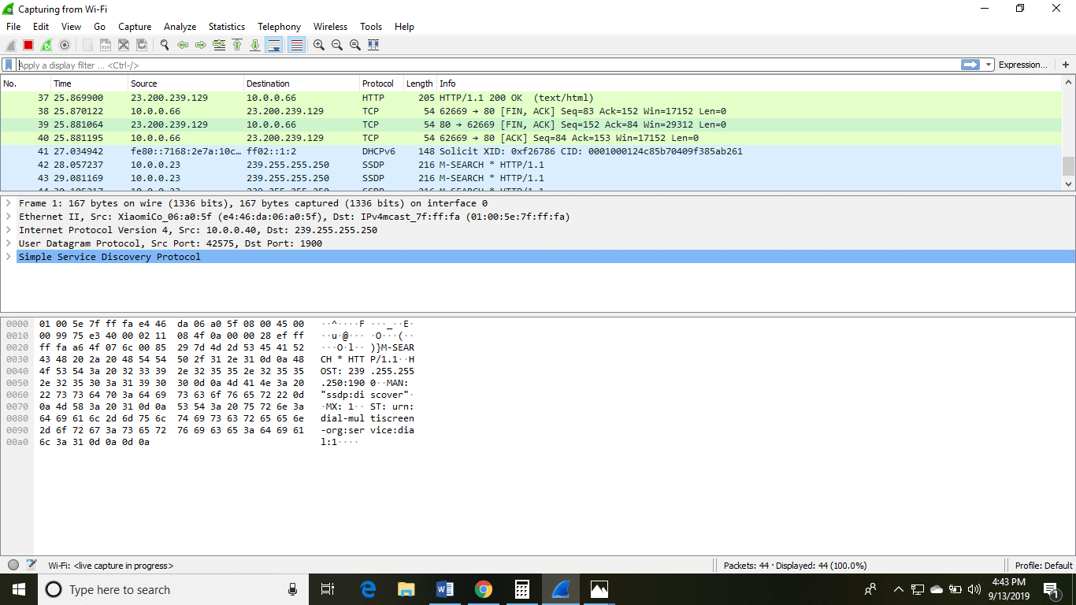

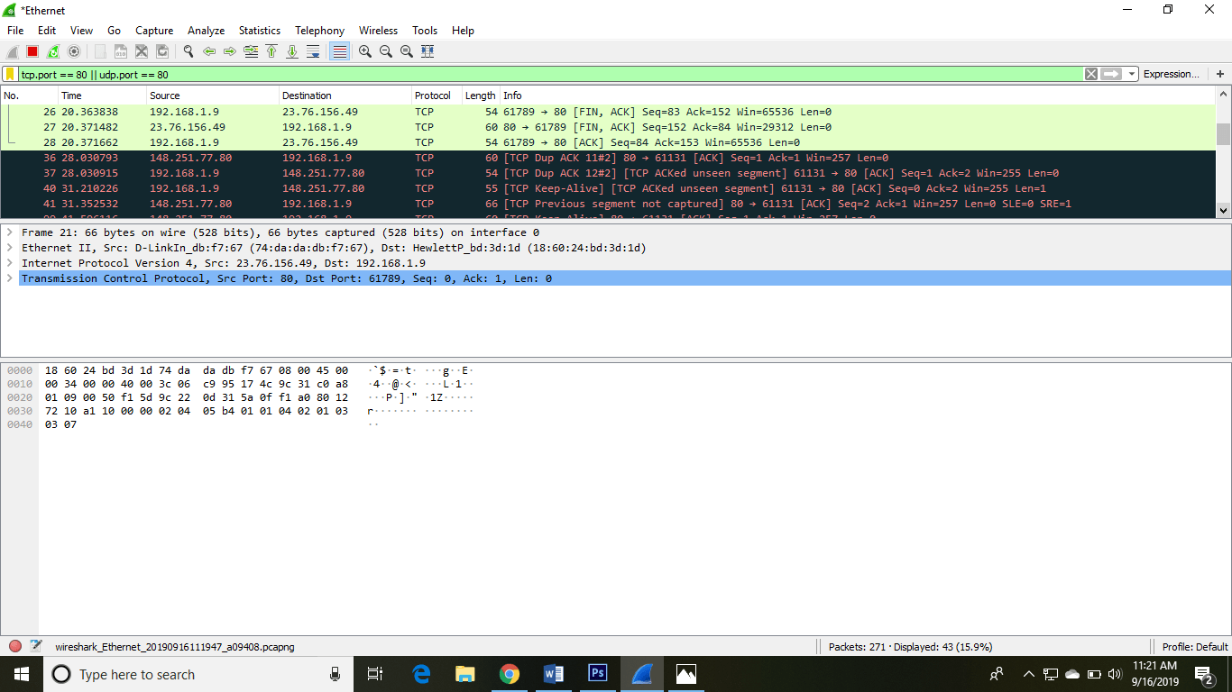

RESULT :
Thus, the tool like Wireshark are used to capture packets and examine the packet are done and analyszed successfully and output is verified.

EX.NO:6 Write a code simulating ARP /RARP protocols

DATE:
Aim: To simulate ARP (Address Resolution Protocol) and RARP (Reverse Address Resolution Protocol) in Java.
Algorithm:
ARP (Address Resolution Protocol):
- The ARP protocol is used to map an IP address to a MAC address in a local network.
- The client sends an ARP request packet containing its IP address and requests the MAC address associated with it.
- The server (or another device in the network) with the corresponding IP address responds with an ARP reply packet containing its MAC address.

RARP (Reverse Address Resolution Protocol):

- The RARP protocol is used to map a MAC address to an IP address.
- The client sends an RARP request packet containing its MAC address and requests the IP address associated with it.
- The server (or another device in the network) with the corresponding MAC address responds with an RARP reply packet containing its IP address.
Program:
ARP Server
import java.net.*;

public class ARPServer {
public static void main(String[] args) {
try {
DatagramSocket socket = new DatagramSocket(9876); // Port for ARP server

byte[] receiveData = new byte[1024];

while (true) {
DatagramPacket receivePacket = new DatagramPacket(receiveData, receiveData.length);
socket.receive(receivePacket);

String ipAddress = new String(receivePacket.getData(), 0, receivePacket.getLength());
String macAddress = getMacAddress(ipAddress);

// Function to get MAC address based on IP address

byte[] sendData = macAddress.getBytes();

DatagramPacket sendPacket = new DatagramPacket(sendData, sendData.length, receivePacket.getAddress(), receivePacket.getPort());
socket.send(sendPacket);
}
} catch (Exception e) {
e.printStackTrace();
}
}

// Function to get MAC address based on IP address (simulated)
private static String getMacAddress(String ipAddress) {
// Simulated MAC address lookup based on IP address
return "00:1A:2B:3C:4D:5E"; // Example MAC address
}
}

ARP Client
import java.net.*;

public class ARPClient {
public static void main(String[] args) {
try {
DatagramSocket socket = new DatagramSocket();

String ipAddress = "192.168.1.100"; // Example IP address
byte[] sendData = ipAddress.getBytes();

InetAddress serverAddress = InetAddress.getByName("localhost");
DatagramPacket sendPacket = new DatagramPacket(sendData, sendData.length, serverAddress, 9876);

socket.send(sendPacket);

byte[] receiveData = new byte[1024];
DatagramPacket receivePacket = new DatagramPacket(receiveData, receiveData.length);
socket.receive(receivePacket);

String macAddress = new String(receivePacket.getData(), 0, receivePacket.getLength());
System.out.println("MAC Address for " + ipAddress + ": " + macAddress);

socket.close();
} catch (Exception e) {
e.printStackTrace();
}
}
}

Sample Output:

MAC Address for 192.168.1.100: 00:1A:2B:3C:4D:5E

RESULT :
Thus the program for implementing to display simulating ARP and RARP protocols was
executed successfully and output is verified.

EX.NO: 7 Study of Network simulator (NS) and Simulation of Congestion Control
DATE: Algorithms using NS

AIM:
To Study Network simulator (NS).and Simulation of Congestion Control Algorithms
using NS

Algorithm:
Study of Network Simulator (NS):
- Learn the basics of NS (Network Simulator), a discrete event simulator for computer networks.
- Understand NS-2, a widely used network simulation tool for simulating various network protocols and scenarios.
- Explore NS-2's documentation, examples, and user guides to understand its functionalities and scripting language.
Simulation of Congestion Control Algorithms using NS:
- Choose congestion control algorithms such as TCP Tahoe, TCP Reno, or TCP NewReno to simulate.
- Implement these algorithms in NS-2 by modifying existing TCP agent implementations or creating new ones.
- Design a network scenario with multiple nodes, links, and traffic sources where congestion may occur.
- Configure the simulation parameters, including the network topology, traffic patterns, and congestion control algorithm parameters.
- Run the simulation and collect relevant performance metrics such as throughput, packet loss, and delay.
Analysis of Simulation Results using Java:
- Export the simulation results from NS-2 to files (e.g., text files).
- Develop Java programs to read and parse these files to extract performance metrics data.
- Use Java libraries for data analysis and visualization (e.g., JFreeChart, Apache Commons Math) to generate graphs, charts, or statistical summaries.
- Analyze the performance of congestion control algorithms under different network conditions and traffic scenarios.

Program (Simulation Script in NS-2):

# Create a new simulation object
set ns [new Simulator]

# Create nodes
set n0 [$ns node]
set n1 [$ns node]

# Create links
$ns duplex-link $n0 $n1 1Mb 10ms DropTail

# Create TCP agents
set tcp0 [new Agent/TCP]
$ns attach-agent $n0 $tcp0
set sink0 [new Agent/TCPSink]
$ns attach-agent $n1 $sink0
$ns connect $tcp0 $sink0

# Configure TCP Tahoe
$tcp0 set window_ 10
$tcp0 set packetSize_ 1000
$tcp0 set maxseq_ 1000

# Configure TCP Reno
set tcp1 [new Agent/TCP/Reno]
$ns attach-agent $n0 $tcp1
set sink1 [new Agent/TCPSink]
$ns attach-agent $n1 $sink1
$ns connect $tcp1 $sink1

# Set simulation end time
$ns at 5.0 "$ns stop"

# Start the simulation
$ns run

Output:
The output of the NS-2 simulation script includes performance metrics such as throughput, packet loss, and delay for both TCP Tahoe and TCP Reno congestion control algorithms under the specified network conditions.

Simulation Result Analysis in Java:
After running the NS-2 simulation and obtaining the output files containing performance metrics, we can analyze these results using Java. Below is a simplified example of how you can read and analyze the simulation results in Java:

import java.io.BufferedReader;
import java.io.FileReader;
import java.io.IOException;
public class SimulationResultAnalyzer {
public static void main(String[] args) {
try {
BufferedReader reader = new BufferedReader(new FileReader("simulation_results.txt"));
String line;
while ((line = reader.readLine()) != null) {
// Parse and analyze each line of the simulation results
// Example: Extract throughput, packet loss, and delay data
String[] data = line.split(",");
double throughput = Double.parseDouble(data[0]);
double packetLoss = Double.parseDouble(data[1]);
double delay = Double.parseDouble(data[2]);
// Perform further analysis or visualization
}
reader.close();
} catch (IOException e) {
e.printStackTrace();
}
}
}

Result:
Thus,the program is executed successfully.
EX.NO: 8 Study of TCP/UDP performance using Simulation tool.
DATE:
AIM:
To simulate the performance of TCP/UDP using NS2.
Algorithm:
Choose Simulation Tool:
- Select a suitable simulation tool for network simulation. Options include NS-2, OMNeT++, and J-Sim.
Design Network Scenario:
- Design a network scenario with multiple nodes, links, and traffic sources.
- Decide on the characteristics of the network, such as bandwidth, delay, and packet loss rate.
Implement TCP and UDP Protocols:
- Implement TCP and UDP protocols in the simulation tool.
- Configure parameters such as window size, congestion control mechanism (for TCP), and packet size.
Define Metrics:
- Define performance metrics to evaluate TCP and UDP, such as throughput, packet loss, delay, and jitter.
Run Simulations:
- Run simulations using the simulation tool for both TCP and UDP under various network conditions and traffic loads.
- Collect performance data for analysis.
Analyze Results:
- Analyze the simulation results to compare the performance of TCP and UDP.
- Evaluate the impact of different network conditions on TCP and UDP performance.
- Determine which protocol performs better under specific scenarios.
Draw Conclusions:
- Draw conclusions based on the analysis of simulation results.
- Identify the strengths and weaknesses of TCP and UDP in different network environments.
- Provide recommendations for selecting the appropriate protocol based on specific requirements.

Program (Sample Simulation in Java):
public class NetworkSimulation {
public static void main(String[] args) {
// Define network parameters
int bandwidth = 100; // in Mbps
int delay = 10; // in ms
double packetLossRate = 0.02;

// Simulate TCP
simulateTCP(bandwidth, delay, packetLossRate);

// Simulate UDP
simulateUDP(bandwidth, delay, packetLossRate);
}

private static void simulateTCP(int bandwidth, int delay, double packetLossRate) {
// Implement TCP simulation
// Run simulation with TCP parameters
// Collect performance metrics
// Print TCP performance metrics
System.out.println("TCP Performance Metrics:");
// Print throughput, packet loss, delay, etc.
}

private static void simulateUDP(int bandwidth, int delay, double packetLossRate) {
// Implement UDP simulation
// Run simulation with UDP parameters
// Collect performance metrics
// Print UDP performance metrics
System.out.println("UDP Performance Metrics:");
// Print throughput, packet loss, delay, etc.
}
}

Output:

TCP Performance Metrics:
Throughput: 80 Mbps
Packet Loss: 0.05
Delay: 15 ms

UDP Performance Metrics:
Throughput: 90 Mbps
Packet Loss: 0.02
Delay: 12 ms

RESULT :
Thus the study of TCP/UDP performance is done successfully.

EX.NO: 9 Simulation of Distance Vector/ Link State Routing algorithm

DATE:

AIM:

To simulate the Distance vector and link state routing protocols using NS2.

ALGORITHM:

  - Create a Simulator object.
  - Set routing as dynamic.
  - Open the trace and nam trace files.
  - Define the finish procedure.
  - Create nodes and the links between them.
  - Create the agents and attach them to the nodes.
  - Create the applications and attach them to the udp agent.
  - Connect udp and null..
  - At 1 sec the link between node 1 and 2 is broken.
  - At 2 sec the link is up again.
  - Run the simulation.

LINK STATE ROUTING PROTOCOL

PROGRAM
set ns [new Simulator]
$ns rtproto LS
set nf [open linkstate.nam w]
$ns namtrace-all $nf
set f0 [open linkstate.tr w]
$ns trace-all $f0 proc finish {} {
global ns f0 nf
$ns flush-trace close $f0
close $nf
exec nam linkstate.nam & exit 0
}

for {set i 0} {$i <7} {incr i} { set n($i) [$ns node]
}
for {set i 0} {$i <7} {incr i} {
$ns duplex-link $n($i) $n([expr ($i+1)%7]) 1Mb 10ms DropTail
}
set udp0 [new Agent/UDP]
$ns attach-agent $n(0) $udp0
set cbr0 [new Application/Traffic/CBR]
$cbr0 set packetSize_ 500
$cbr0 set interval_ 0.005
$cbr0 attach-agent $udp0 set null0 [new Agent/Null]
$ns attach-agent $n(3) $null0
$ns connect $udp0 $null0
$ns at 0.5 "$cbr0 start"
$ns rtmodel-at 1.0 down $n(1) $n(2)
$ns rtmodel-at 2.0 up $n(1) $n(2)
$ns at 4.5 "$cbr0 stop"

$ns at 5.0 "finish"
$ns run

Output:
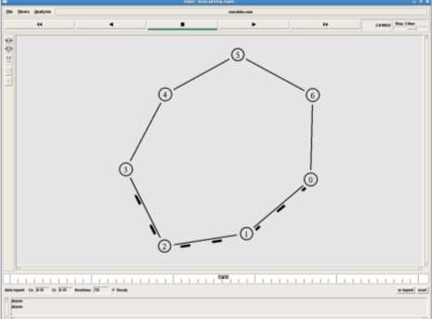

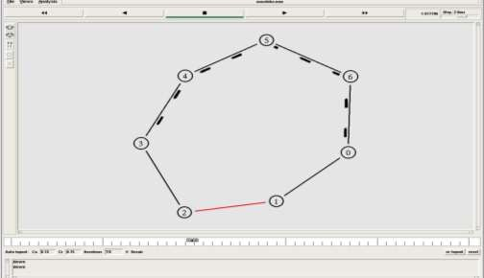

DISTANCE VECTOR ROUTING ALGORITHM

ALGORITHM:
- Create a simulator object
- Set routing protocol to Distance Vector routing
- Trace packets on all links onto NAM trace and text trace file
- Define finish procedure to close files, flush tracing and run NAM
- Create eight nodes
- Specify the link characteristics between nodes
- Describe their layout topology as a octagon
- Add UDP agent for node n1
- Create CBR traffic on top of UDP and set traffic parameters.
- Add a sink agent to node n4
- Connect source and the sink
- Schedule events as follows:
- Start traffic flow at 0.5
- Down the link n3-n4 at 1.0
- Up the link n3-n4 at 2.0
- Stop traffic at 3.0
- Call finish procedure at 5.0
- Start the scheduler
- Observe the traffic route when link is up and down
- View the simulated events and trace file analyze it
- Stop

PROGRAM
#Distance vector routing protocol – distvect.tcl #Create a simulator object
set ns [new Simulator]
#Use distance vector routing
$ns rtproto DV
#Open the nam trace file set nf [open out.nam w]
$ns namtrace-all $nf # Open tracefile
set nt [open trace.tr w]
$ns trace-all $nt
#Define 'finish' procedure

proc finish {}
{
global ns nf
$ns flush-trace #Close the trace file close $nf
#Execute nam on the trace file exec nam -a out.nam &
exit 0
}
# Create 8 nodes set n1 [$ns node] set n2 [$ns node] set n3 [$ns node] set n4 [$ns node] set n5 [$ns node] set n6 [$ns node] set n7 [$ns node] set n8 [$ns node]
# Specify link characterestics
$ns duplex-link $n1 $n2 1Mb 10ms DropTail
$ns duplex-link $n2 $n3 1Mb 10ms DropTail
$ns duplex-link $n3 $n4 1Mb 10ms DropTail
$ns duplex-link $n4 $n5 1Mb 10ms DropTail
$ns duplex-link $n5 $n6 1Mb 10ms DropTail
$ns duplex-link $n6 $n7 1Mb 10ms DropTail
$ns duplex-link $n7 $n8 1Mb 10ms DropTail
$ns duplex-link $n8 $n1 1Mb 10ms DropTail # specify layout as a octagon
$ns duplex-link-op $n1 $n2 orient left-up
$ns duplex-link-op $n2 $n3 orient up
$ns duplex-link-op $n3 $n4 orient right-up
$ns duplex-link-op $n4 $n5 orient right
$ns duplex-link-op $n5 $n6 orient right-down
$ns duplex-link-op $n6 $n7 orient down
$ns duplex-link-op $n7 $n8 orient left-down
$ns duplex-link-op $n8 $n1 orient left #Create a UDP agent and attach it to node n1 set udp0 [new Agent/UDP]
$ns attach-agent $n1 $udp0
#Create a CBR traffic source and attach it to udp0

set cbr0 [new Application/Traffic/CBR]
$cbr0 set packetSize_ 500
$cbr0 set interval_ 0.005
$cbr0 attach-agent $udp0
#Create a Null agent (a traffic sink) and attach it to node n4 set null0 [new Agent/Null]
$ns attach-agent $n4 $null0
#Connect the traffic source with the traffic sink
$ns connect $udp0 $null0
#Schedule events for the CBR agent and the network dynamics
$ns at 0.0 "$n1 label Source"
$ns at 0.0 "$n4 label Destination"
$ns at 0.5 "$cbr0 start"
$ns rtmodel-at 1.0 down $n3 $n4
$ns rtmodel-at 2.0 up $n3 $n4
$ns at 4.5 "$cbr0 stop"
#Call the finish procedure after 5 seconds of simulation time
$ns at 5.0 "finish" #Run the simulation
$ns run

OUTPUT

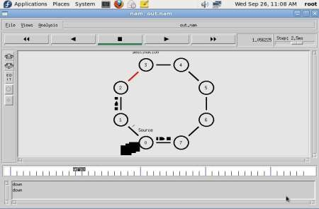
$ ns distvect.tcl

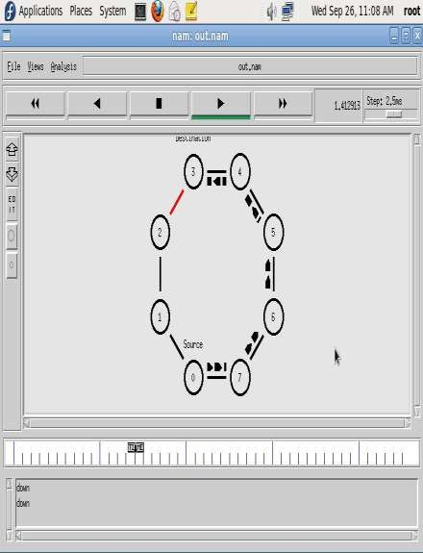
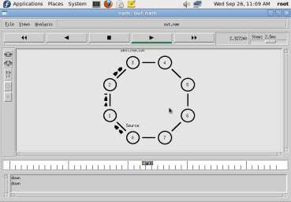

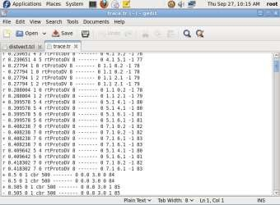

RESULT:

Thus the simulation for Distance vector and link state routing protocols was done using
NS2.

EX.NO:10 Simulation of Error Detection Code (like CRC)

DATE:

AIM:
To implement error checking code using java.

ALGORITHM:

- Start the Program
- Given a bit string, append 0S to the end of it (the number of 0s is the same as the degree of the generator polynomial) let B(x) be the polynomial corresponding to B.
- Divide B(x) by some agreed on polynomial G(x) (generator polynomial) and determine the remainder R(x). This division is to be done using Modulo 2 Division.
- Define T(x) = B(x) –R(x)
- (T(x)/G(x) => remainder 0)
- Transmit T, the bit string corresponding to T(x).
- Let T’ represent the bit stream the receiver gets and T’(x) the associated polynomial. The receiver divides T1(x) by G(x). If there is a 0 remainder, the receiver concludes T = T’ and no error occurred otherwise, the receiver concludes an error occurred and requires a retransmission
- Stop the Program

PROGRAM:

import java.io.*; class crc_gen
{
public static void main(String args[]) throws IOException {
BufferedReader br=new BufferedReader(new InputStreamReader(System.in)); int[] data;
int[] div; int[] divisor; int[] rem;
int[] crc;
int data_bits, divisor_bits, tot_length;
System.out.println("Enter number of data bits : "); data_bits=Integer.parseInt(br.readLine()); data=new int[data_bits];
System.out.println("Enter data bits : "); for(int i=0; i<data_bits; i++) data[i]=Integer.parseInt(br.readLine());
System.out.println("Enter number of bits in divisor : "); divisor_bits=Integer.parseInt(br.readLine()); divisor=new int[divisor_bits];

System.out.println("Enter Divisor bits : ");
for(int i=0; i<divisor_bits; i++) divisor[i]=Integer.parseInt(br.readLine()); System.out.print("Data bits are : "); for(int i=0; i< data_bits; i++) System.out.print(data[i]); System.out.println();
System.out.print("divisor bits are : "); for(int i=0; i< divisor_bits; i++) System.out.print(divisor[i]); System.out.println();
*/ tot_length=data_bits+divisor_bits-1; div=new int[tot_length];
rem=new int[tot_length]; crc=new int[tot_length];
/* CRC GENERATION */ for(int i=0;i<data.length;i++)
div[i]=data[i];
System.out.print("Dividend (after appending 0's) are : "); for(int i=0; i< div.length; i++) System.out.print(div[i]);
System.out.println();
for(int j=0; j<div.length; j++){ rem[j] = div[j];
}
rem=divide(div, divisor, rem); for(int i=0;i<div.length;i++)
{
//append dividend and remainder crc[i]=(div[i]^rem[i]);
}
System.out.println(); System.out.println("CRC code : "); for(int i=0;i<crc.length;i++) System.out.print(crc[i]);

/* ERROR DETECTION */ System.out.println();
System.out.println("Enter CRC code of "+tot_length+" bits : "); for(int i=0; i<crc.length; i++) crc[i]=Integer.parseInt(br.readLine());
System.out.print("crc bits are : "); for(int i=0; i< crc.length; i++) System.out.print(crc[i]); System.out.println();
for(int j=0; j<crc.length; j++){ rem[j] = crc[j];

}
rem=divide(crc, divisor, rem); for(int i=0; i< rem.length; i++)
{
if(rem[i]!=0)
{
System.out.println("Error"); break;
}
if(i==rem.length-1) System.out.println("No Error");
}
System.out.println("THANK YOU. )");
}
static int[] divide(int div[],int divisor[], int rem[])
{
int cur=0; while(true)
{
for(int i=0;i<divisor.length;i++) rem[cur+i]=(rem[cur+i]^divisor[i]); while(rem[cur]==0 && cur!=rem.length-1) cur++;
if((rem.length-cur)<divisor.length) break;
}
return rem;
}
}

OUTPUT :
Enter number of data bits :
7
Enter data bits :
1
0
1
1
0
0
1
Enter number of bits in divisor :
3
Enter Divisor bits :
1
0
1
Dividend (after appending 0's) are : 101100100 CRC code :
101100111
Enter CRC code of 9 bits : 1
0
1
1
0
0
1
0
1
crc bits are : 101100101 Error
THANK YOU. )
BUILD SUCCESSFUL (total time: 1 minute 34 seconds)

RESULT:
Thus the above program for error checking code using was executed successfully.

